

**e-Yantra Robotics Competition**

**Theme: Cross a Crater**

**<Team ID>**

|  |  |
| --- | --- |
| **Team leader name** | **Vaibhav Vivek** |
| **College** | **Maharaja Agrasen Institute of Technology** |
| **Email-id** | **vaibhavvivek28@ieee.org** |
| **date** | **24-12-16** |

**This is the second part of the Qualifier Test for the Stage 2 of eYRC - 2016. Please carefully go through the instructions below:**

* This is the Subjective Question. You have been provided with a scenario whose solution will require the experiences you gained in solving the Task1 and Task2 of the Stage 1 of the Cross_A_Crater theme.
* You have **60-minute** deadline to upload the solution in a **zip** folder named ‘**STT#your_team_id**’.
  + You should ideally spend 10 minutes in reading and planning the solution.
  + 20 minutes for drafting the solution.
  + 10-15 minutes for proof reading and drawing relevant flow charts and diagrams
  + 10-15 minutes preparing the solution for uploading,

**Scenario**

**You have been provided with a Robot that has a distance sensor attached to it. The robot is getting a wireless stream of a arena (as shown in Figure 1) from an overhead camera. The robot has to start from point A in the grid and reach point B in the grid avoiding the obstacles. Obstacles are placed at random positions on the arena and are of a particular color and a fixed size.**

**Considering the above scenario your solution should explain:**

* **Arena Sensing using overhead camera (1)**
* **Obstacles and Digit detections (3)**
  + ***Hint:*  Use of distance sensor or color to identify obstacles**
* **Path construction/planning (4)**
* **Path navigation by the Robot over the numbers so that the route constitutes the smallest possible sum to reach Point B (4)**
  + ***Hint:* Robot localisation and orientation in the arena using color markers**

You can create separate algorithms, figures and flowcharts to illustrate above 4 points. You may draw the figures/flowcharts on rough papers and add to your solution by taking a snapshot/scan of those papers.

Remember this is not an essay, your solution/algorithm should be succinct and precise.

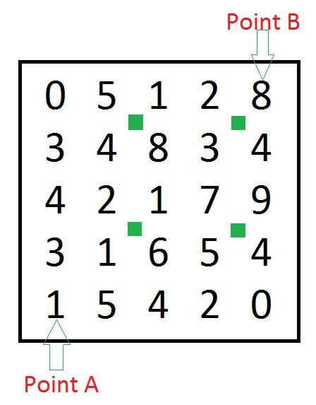

**Figure 1: Sample Arena (only for reference)**

**Sample Path Outputs:**

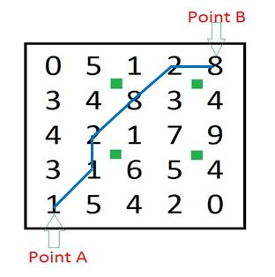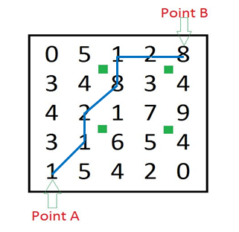

**Figure 2: Sample Path 1(Sum=22) Figure 2: Sample Path 1(Sum=23)**